**NUTRITION API ACCOUNT CREATION**

**TEAM LEADER-DHIVYA**

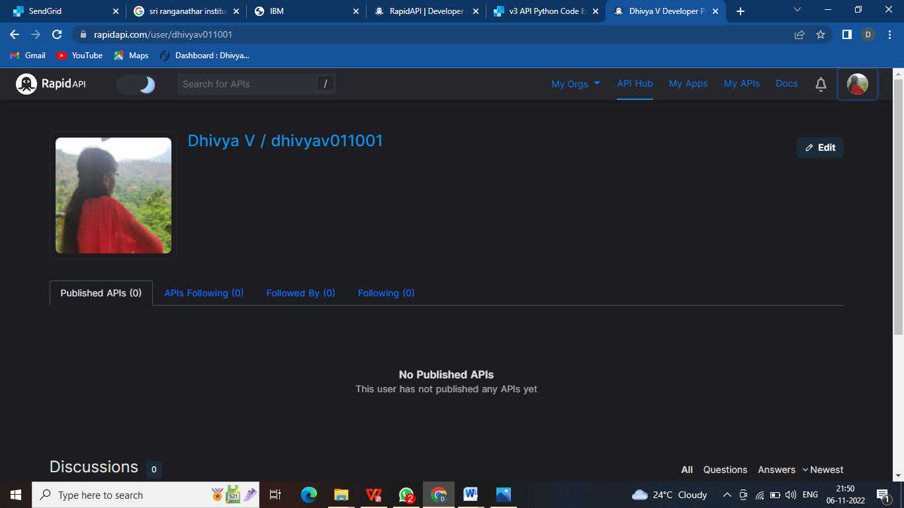

**TEAM MEMBER-HEROSHA**

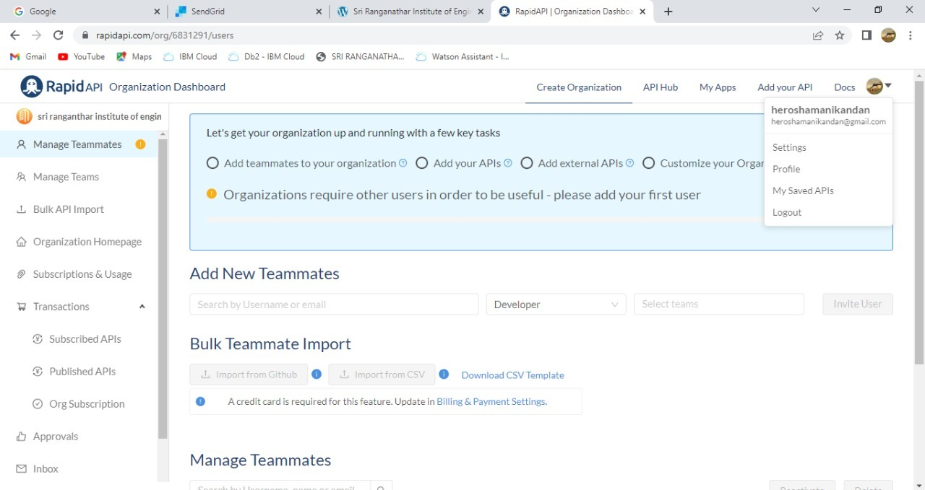

**TEAM MEMBER –GAYATHRI**

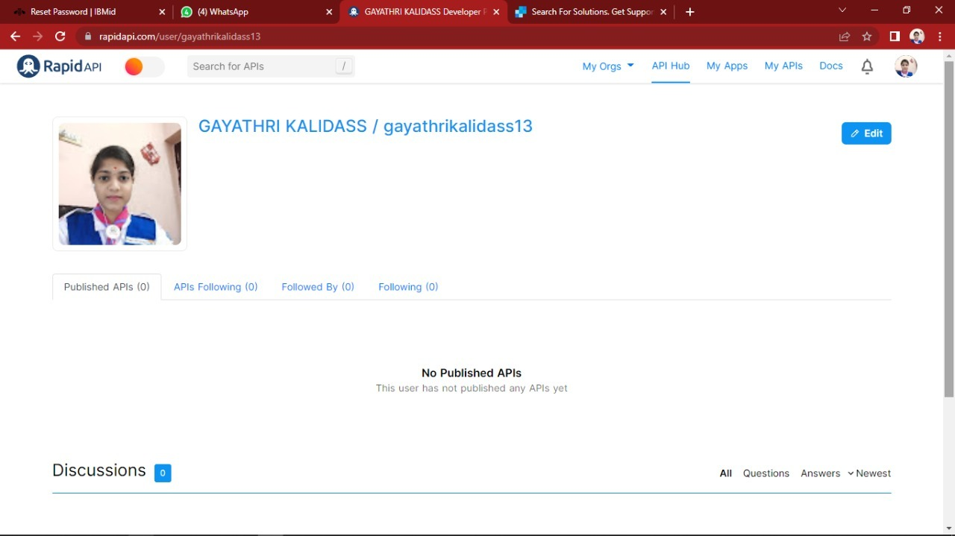

**TEAM MEMBER –SAHAYA DELPHIN**

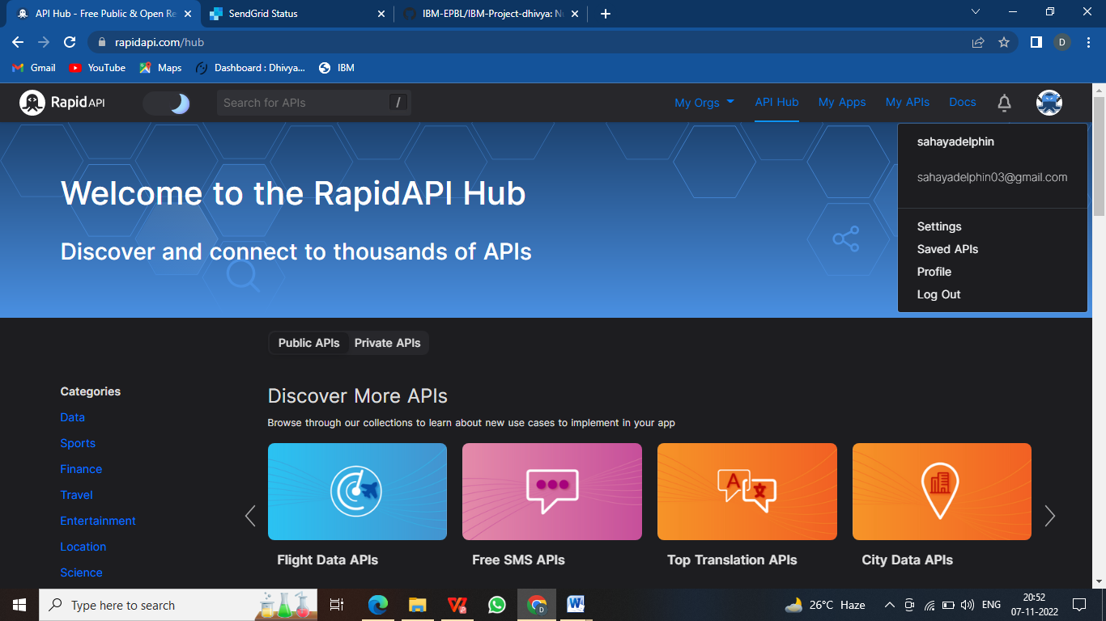

**TEAM MEMBER –SANJANA DEVI**

